Empirical Ionospheric Model Based on Arecibo Incoherent Scatter Radar Data

Ashley Brooks

Valparaiso University, Valparaiso, Indiana

Haystack Observatory, Massachusetts Institute of Technology, Westford Massachusetts

Abstract

In order to illustrate the properties of the ionosphere and improve prediction capabilities, empirical models of electron density, electron temperature, and ion temperature have previously been created from Millstone Hill incoherent scatter radar data. A new model for the Arecibo radar has now been developed using the software used for the previous models, Saint Santin and MU. The Arecibo Empirical Model operates on data from the years 1970 to 2002, which has been gathered through the CEDAR/ MADRIGAL database. Electron density, electron temperature, ion temperature, and parallel ion velocity variations from 150km to 650km are analyzed with respect to day number, local time, altitude, solar activity (F10.7), and geomagnetic activity (ap). The error estimates for the model parameters, which were not available for the St. Santin Model, are also provided here. Due to the close proximity in geomagnetic latitude, the Arecibo Empirical Model and the Middle and Upper Atmosphere (MU) Model are compared.

Introduction

Incoherent scatter radars are used to look at ionized layers in the earth's upper atmosphere and are considered to be the most powerful ground-based instrument to detect the ionosphere. Direct evidence for the existence of the ionized layers has been around since 1925 based upon the early experiments of Appleton and Barnett. Due to increasing amounts of data, empirical modeling of the ionosphere has become feasible. Empirical models already created using Incoherent Scatter Radar data are Millstone Hill (42.6N, 288.5W) in the United States, Saint Santin in France (44.6N, 2.2E), Shigaraki (the MU radar site) in Japan (34.8N, 136.1E), and now the Arecibo model. These models were created using a technique first developed for the Millstone Hill model (Holt et al, 2002), and provide descriptions for basic parameters such as electron density (N_{e}), ion temperature (T_{i}), and electron temperature (T_{e}). The Saint Santin model (Zalucha, 2003) includes data from 1966 to 1987, and the MU radar model, as the only such model

for East Asia, includes data between 1986 and 2002.
Arecibo, in Puerto Rico, is located at 18.3N, 66.7W with an operating frequency of 430 Mhz. Data for Arecibo is located in the CEDAR/MADRIGAL database for the years 1970 until 2002 making the long term measuring of parameters N_{e}, T_{i}, T_{e}, and line-of-sight ion velocity possible. The parallel ion velocity is derived from the line-of-sight ion velocity. In this paper the modeling technique is presented along with the Arecibo data distribution. Variations of the parameters are analyzed and the results presented with respect to day number, local time, altitude, solar activity (F10.7), and geomagnetic activity (ap). The error estimates for the model parameters, which were not available for the Saint Santin Model, are also provided. The Arecibo model covers altitudes from 150km to 650km. Due to the close proximity in geomagnetic latitude, comparisons between the Arecibo Empirical Model (30N) and the MU radar model (27.2N) are made for the ionospheric F2 region heights.

Method

First the data in the madrigal database for Arecibo is sorted into smaller more manageable files based upon the day of the experiment in order to be able to run the Isprint program. Then the data is extracted for each month and stored into individual directories for the next-step binning and fitting. Experimental data with CEDAR “kind of data” codes 2010, 30001, 30002, 30003, 30009, and 300015 are used in an attempt to secure a proper amount of data for modeling. The electron density, ion temperature, electron temperature, and parallel ion velocity variables are separated into altitude and local time bins for each month. Each month of data for the seasonal bin contains three months worth of data. This is in order to increase the number of data points and model accuracy. The data is further binned into hourly local time bins and then modeling of the altitude variations by a piecewise linear functions at different nodes occurs [Zhang and Holt, 2002]. There are fifteen nodes. Each one is determined according to the height points for one of the main experiments modes. They are 145, 182, 219, 256, 293, 330, 367, 405, 442, 479, 516, 553, 590, and 627km. The Arecibo model uses a least-square-fit equation to determine the altitude, solar activity and magnetic activity dependences using F10.7 index for the previous day and ap index for the previous three hours [Zhang and Holt, 2002].

P = α₀ + α₁ ×ƒ + α₂ × a (1)

P is one of the measured parameters (Nel, T_{i}, T_{e}, or parallel ion velocity), ƒ ((F10.7-135) / 100) is the normalized F10.7 index, α₀, α₁, and α₂ are the fitting coefficients, and a ((ap – 15) / 10) is the normalized ap index. The model error is obtained by calculating the model and data difference for each point of the data and finding the root of the mean of the squared difference (r.m.s.).

Data Distribution

The total number of points for this study is 20309913. There are an average of 387218 points per height and 451754 per month for Nel. The summer months experience lower point returns and the winter months the highest returns (Figure 1a). The local time distribution remains fairly constant with a slight peak in the early morning and afternoon hours (Figure 1b). The greatest distribution of points occurs within the altitude range of 350km to 400km, with minimum around 180km and 590km. The rest of the height data point range remains fairly constant around 400000 points (Figure 1c). Figure 1d shows the number of data points for all months, solar activity, and magnetic activity levels. The ap distribution ranges from 0 to the 80s. The data points decrease almost exponentially as the ap index number reaches higher values (Figure 2). F10.7 has a large data point return from 60 to 90, a minimum at 135 and 255, and remains fairly steady through the rest of the F10.7 range (Figure 3).

Results

Arecibo Model Analysis

To present the model behavior, the model values are organized and plotted according to altitude, F10.7, ap index, local time, and day number. There is an increase in temperatures at higher altitudes during the spring and fall. This is evident in figure 4, which shows a four panel plot of Nel, T_{e}, T_{i}, and parallel ion velocity with respect to day number versus altitude. There is an inverse relation between electron density and electron temperature. Figure 5, also a four panel plot, shows the local time versus altitude. The daytime hours see an increase in electron density in the F2 region. At low altitudes, coupling of ions to the colder neutrals dominates that to the hotter electrons [Zhang and Holt, 2002]. This accounts for the cooler low levels and the warmer high levels in which there is more coupling with the electrons than the neutrals. There is an upward parallel ion velocity during the morning hours, whereas a majority of the rest of the day experiences a downward motion. Figure 6a illustrates diurnal changes of Nel, T_{i}, T_{e}, and parallel ion velocity for December. The dots are observations and are plotted with low geomagnetic activity (ap 0-10), various F10.7 ranges, and two altitudes (215-225km and 325-335km). The lines are for the model. The blue line depicts an F10.7 of 80, the dashed blue line demonstrates an F10.7 value of 150, and the green line shows an F10.7 of 220. Good model consistency can be seen with ion and electron temperatures, as the data points are close to the model results. Model electron density and parallel ion velocity are also in reasonable agreement with the data. Parallel ion velocity has more variability especially during the overnight hours. Nel is in good agreement at lower altitudes, but decreases in consistency at higher altitudes. Figure 6b depicts altitude changes of Nel, T_{i}, T_{e}, and parallel ion velocity for December. Data with F10.7 values between 60 and 360 are shown in addition to the afore mentioned low geomagnetic activity (ap 0-10) from figure 6a. The top row incorporates the local time of hours 19-20 and the bottom row hours 11-13. The model agreement is best for Nel and T_{i}, as the raw data and model results are closely intertwined. Better agreement with all the parameters can be found at lower altitudes.
Error estimates (the r.m.s.) for the model parameters can be found in figures 7a and 7b. Figure 7a incorporates F10.7 (135), day number (90), ap (10) and also has a fixed altitude of 300km. Plotted is local time versus electron density. Nel is plotted versus altitude in 7b. F10.7 (135), day number (90), ap (10), and local time (hour 12) are all held constant. The gray shading represents the error potential, which is very low at lower altitudes and increases slightly with increased altitude. Results for T_{e}, T_{i}, and parallel ion velocity can be found online.

Arecibo and Shigaraki (MU) Model Comparisons

The Arecibo incoherent scatter radar (30N) is within three degrees geomagnetic latitude of the Shigaraki (MU) incoherent scatter radar (27.2N). In addition to this, both models are created using the same Millstone Hill software. This allows for a pertinent comparison between the two models. Figure 8a (Nel), 8b (T_{i}), and 8c (T_{e}) depict day number versus the aforementioned variables. An altitude of 300km illustrates the F2 region. Again the F10.7 index value is 135. The three different plots show the various times of day. Overall electron densities, electron temperatures, and ion temperatures are higher at Arecibo than with the MU model. Electron density has a peak in the late summer to early fall for Arecibo during the overnight and early morning hours. A double peak appears around noontime for the spring and the fall. The nighttime peak for MU electron density occurs mainly during the spring, while the noontime electron density peaks in fall and spring. Ion temperature plots show less of a difference. The peak for Arecibo, overall, usually occurs later in the year than at MU. Electron temperatures show little seasonal change during the nighttime hours. A summertime peak in electron temperature occurs with MU during the daytime hours. Arecibo’s peaks occur at very different times of the year depending on daytime hour.
Figure 9a (Nel), 9b (T_{i}), and 9c (T_{e}) incorporate local time versus the aforementioned variables. F10.7 equals 135 and again the altitude chosen is 300km. The peak in electron density occurs during the daytime hours. This is due to the amount of solar radiation received. At MU, morning enhancement in T_{i} can be seen. This creates a double peak. However, with the Arecibo model the single peak occurs in the afternoon hours. This afternoon peak occurs at roughly the same time as the MU afternoon peak. The double peak in T_{e}, one in the morning and one in the evening, is due to the high electron density during the daytime hours. The higher the electron density the greater the cooling effect for T_{e}. Model comparisons for other altitudes can be found online.

Conclusion

The Arecibo Empirical Model uses incoherent scatter radar data measurements of electron density, electron temperature, ion temperature, and parallel ion velocity. Error estimates for the model parameters in addition to variations in local time, seasons, altitude, F10.7, and ap index are analyzed. The model handles Nel, T_{i}, and T_{e} well, while the parallel ion velocity has higher error estimates. Future models will include data from the EISCAT Svalbard radar in Europe (75.7N, 14.1E) and the radar in Sondrestromfjord, Greenland (63.5N, 45.7W). For more information on the Arecibo model, plots, movies, and real-time images the reader is invited to visit the website given below. www.haystack.mit.edu/madrigal/Models Also available is an interactive section in which the user can vary parameters and plot types.

Acknowledgements

I would like to thank my advisors John Holt and Shun-Rong Zhang for assisting me during this research, Bill Rideout for programming support, Ching Lue for computer assistance, and those responsible for maintaining the Madrigal database. This research was supported by NSF grant 0207748, and the author is supported by NSF grant 0138506.

References

Holt, J.M., S.-R. Zhang, and M.J. Buousauto, Regional and local ionospheric models based on Millstone Hill incoherent scatter radar data, Geophys. Res. Lett., 2002.

Zalucha, Angela, Empirical ionospheric model based on Saint Santin incoherent scatter radar data, REU Final Report, MIT Haystack Observatory, 2003.

Zhang, S.-R. and Holt, J.M., Ionospheric plasma temperatures during 1976-2001 over Millstone Hill, Advances in Space Research, 964, 966, 2002.

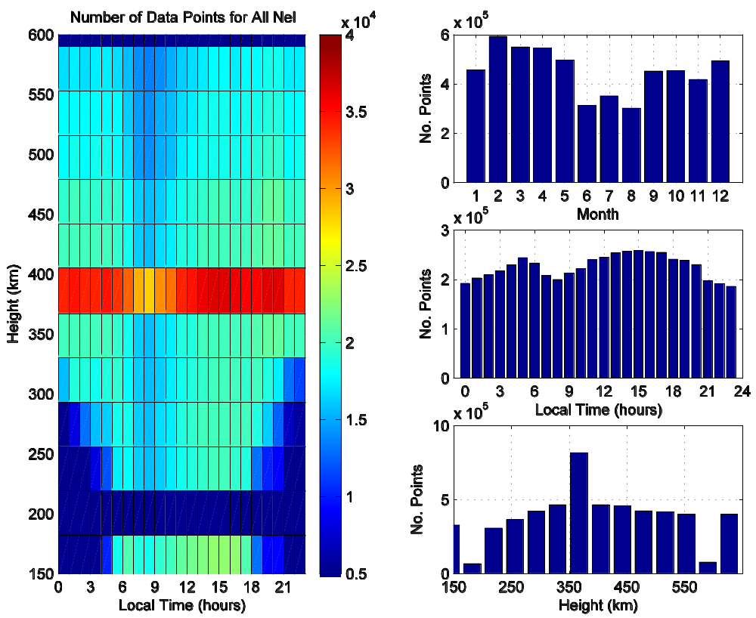
c
b
a
d

Figure 1. The number of points for electron density per month (a), for local time in hours (b), and per altitude in km (c). Distribution of the number of data points for electron density with local time and height (d).

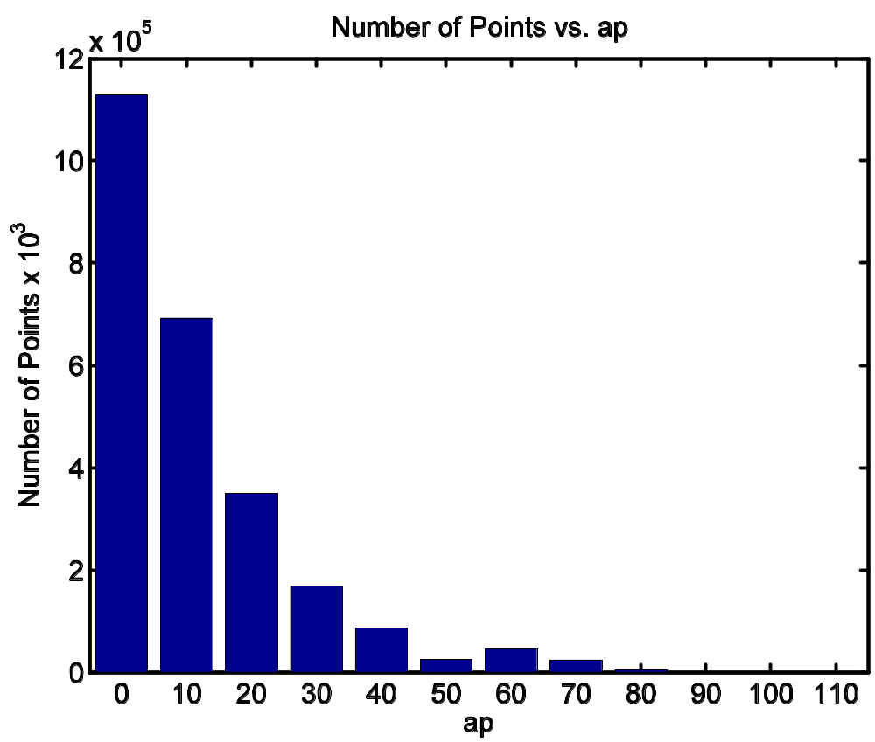

Figure 2. Histogram of the number of points per ap index. The ap index label embodies points between that value and the next value.
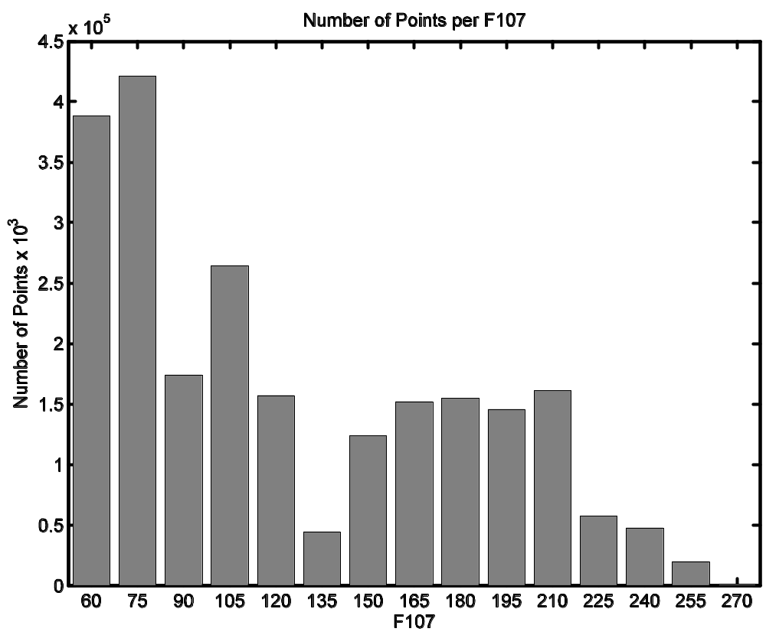

Figure 3. Distribution of points per F10.7. The F10.7 index number label represents points between that value and the next value.

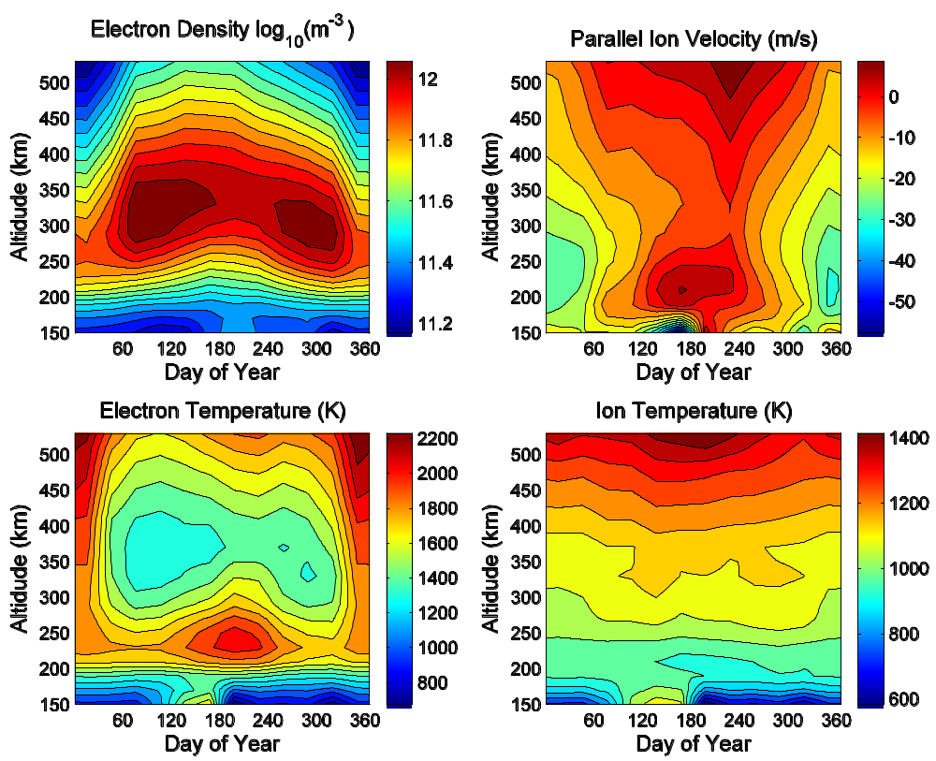

Figure 4. Electron density (upper left), electron temperature in Kelvin (lower left), parallel ion velocity in meters per second (upper right), and ion temperatures (lower right) in Kelvin with varying day of year and altitude. Local time is hour 12.
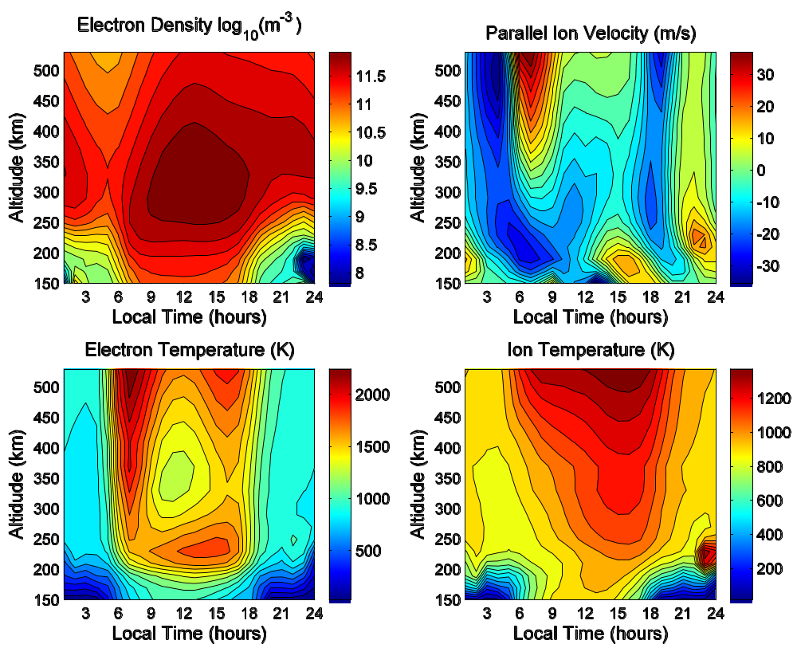

Figure 5. Electron density (upper left), electron temperature in Kelvin (lower left), parallel ion velocity in meters per second (upper right), and ion temperatures (lower right) in Kelvin with varying local time and altitude. Day number equals 90.

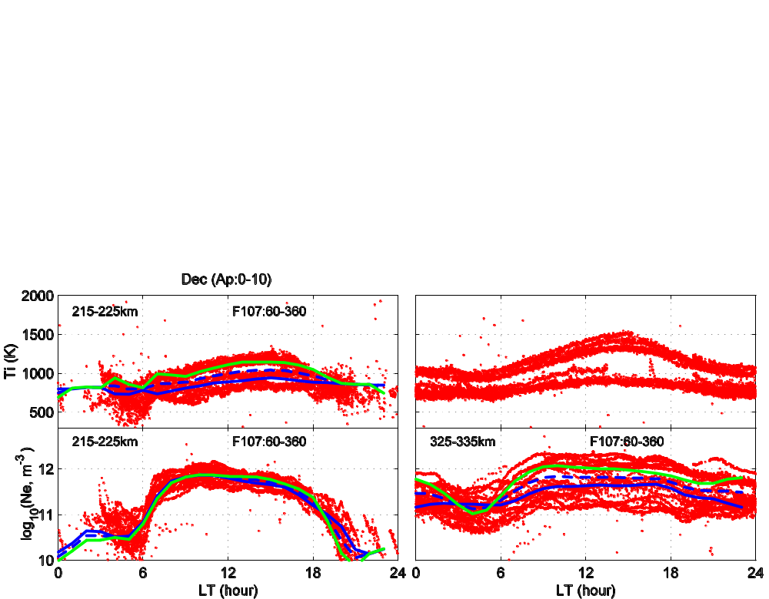

Figure 6a. Depiction of diurnal changes of Nel, T_{i}, T_{e}, and parallel ion velocity for December. F10.7 values between 60 and 360 are shown in addition to the ap index values of 0-10. The left column illustrates an altitude of 215-225km and the right column an altitude of 325-335km. Dots represent raw data. Lines show model results. The blue line depicts an F10.7 value of 80, the dashed blue line demonstrates an F10.7 value of 150, and the green line shows an F10.7 of 220.
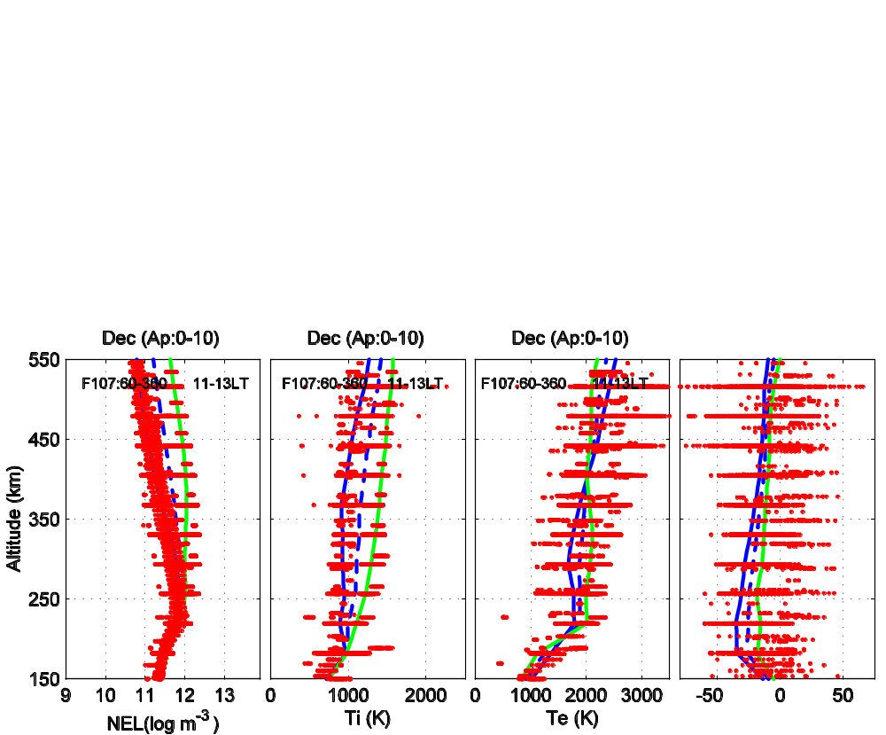

Figure 6b. Depiction of altitude changes of Nel, T_{i}, T_{e}, and parallel ion velocity for December. F10.7 values between 60 and 360 are shown in addition to the ap index values of 0-10. The top row illustrates a local time of 19-20 and the lower row a time of 11-13. Dots represent raw data. Lines show model results. The blue line depicts an F10.7 value of 80, the dashed blue line demonstrates an F10.7 value of 150, and the green line shows an F10.7 of 220.

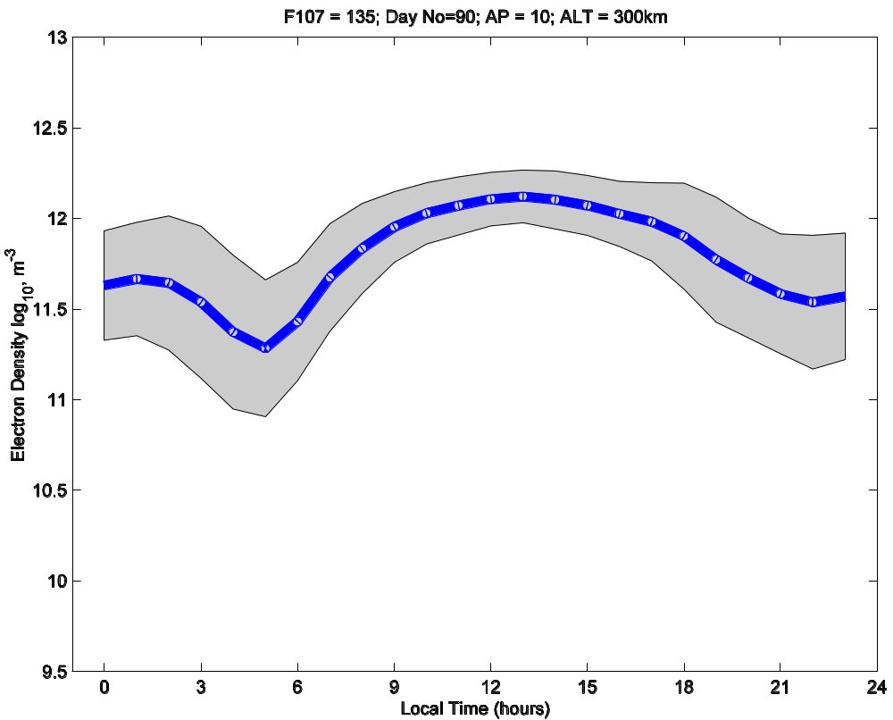

Figure 7a. Error potential for local time and electron density is plotted. F10.7 (135), day number (90), ap (10), and altitude (300km) are all held constant.
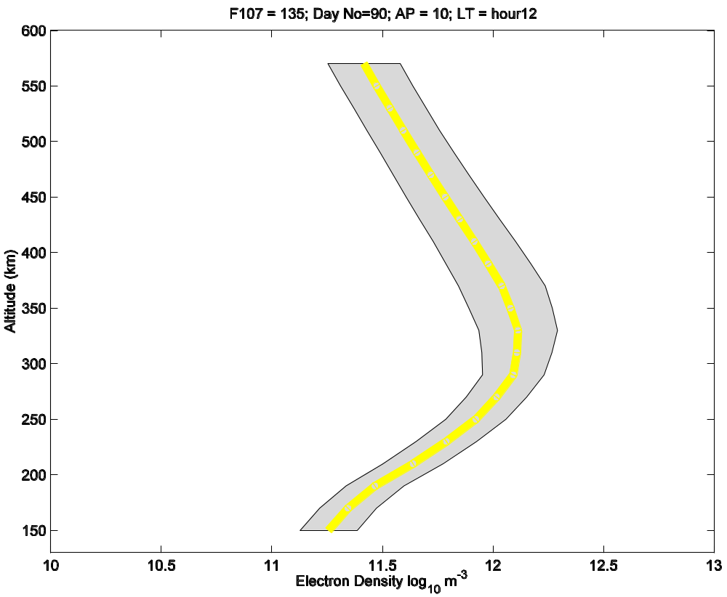

Figure 7b. Error potential for electron density and altitude is plotted. F10.7 (135), day number (90), ap (10), and local time (hour 12) are all held constant.
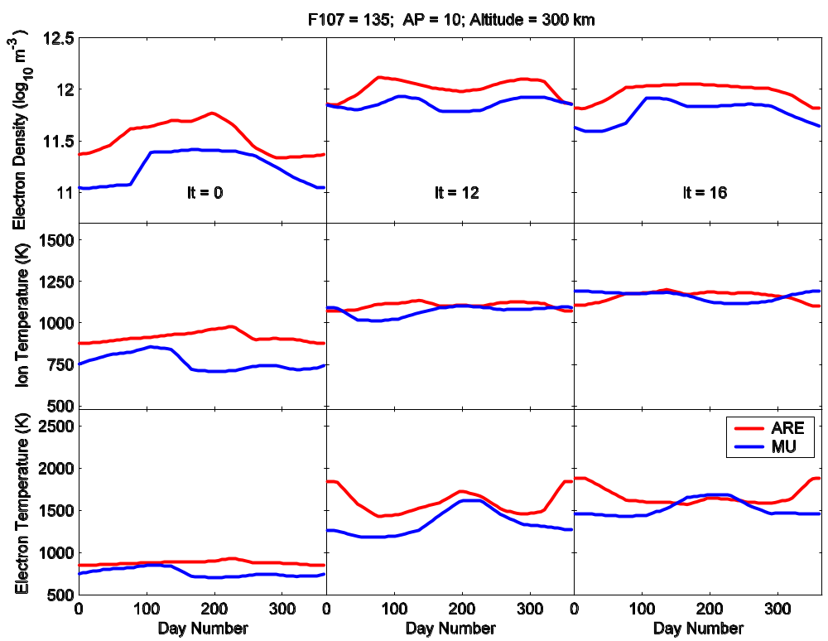

Figure 8. Comparison of the Arecibo and Shigaraki (MU) models with day number and parameters electron density (upper row), ion temperature (middle row), and electron temperature (lower row). The red lines represent the Arecibo model and the blue lines represent the MU model. F10.7=135, ap=10, and an altitude of 300km are presented here for local times of 0, 12, and 16.
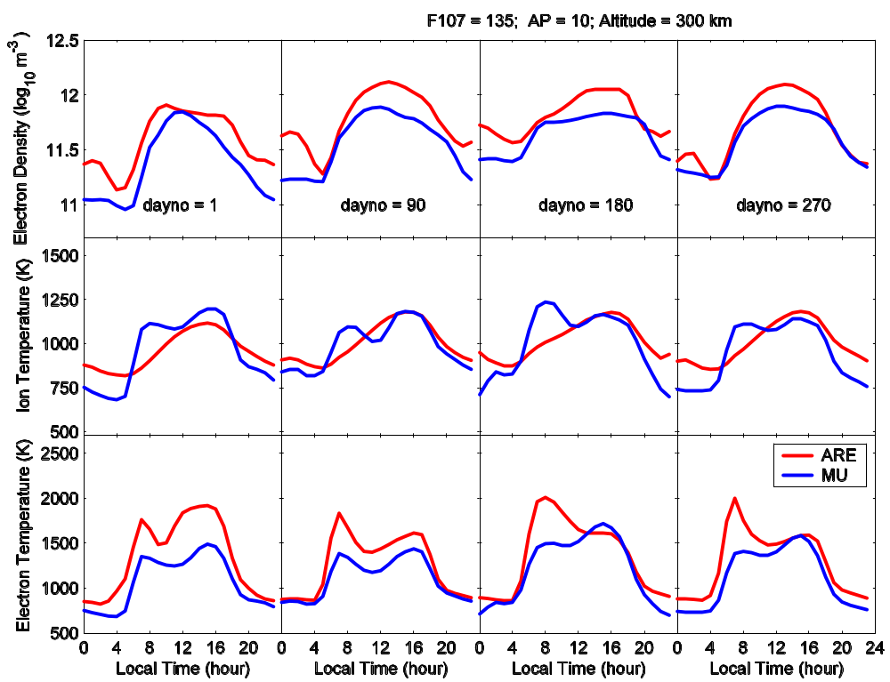

Figure 9. Comparison of the Arecibo and Shigaraki (MU) models with local time and parameters electron density (upper row), ion temperature (middle row), and electron temperature (lower row). The red lines represent the Arecibo model and the blue lines represent the MU model. F10.7=135, ap=10, and an altitude of 300km are presented here for day numbers 1, 90, 180, and 270.

